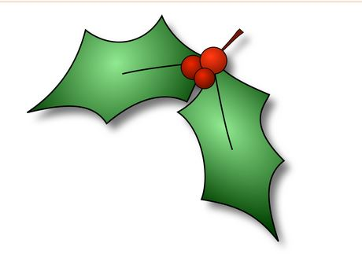
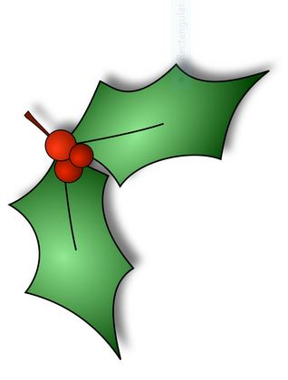
Christmas Nature Diary
After you’ve enjoyed your Christmas dinner and toasted her
Majesty the Queen I want you to raise a glass to Edward Jenner. Why?
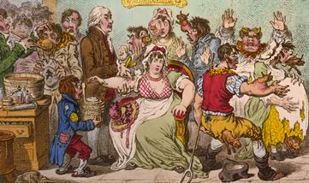
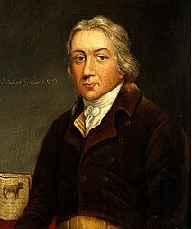
Jenner 1749-1823 was the doctor who discovered the principal of vaccination, something we all will be grateful for in the near future. At that time smallpox, a disfiguring, debilitating and often fatal disease was rife. Jenner noticed that milkmaids who suffered from cowpox, which caused blisters on their hands and arms through constant handling of cows’ udders, never caught smallpox. His theory was that cowpox was a mild form of smallpox. Consequently in 1796 he injected John Phipps, with the watery ooze from cowpox pustules. The boy had two injections and after suffering mild symptoms never caught smallpox. Jenner was unaware of antibodies but his discovery was ground breaking. He treated many people and even sent samples to America. However, as with today, there were anti-vaccers. A cartoon at the time illustrates this brilliantly. I like the man with the cow growing out of his nose. Jenner’s work has saved billions of lives and in 1980 the World Health Organisation declared the world free of smallpox. Cheers Edward!
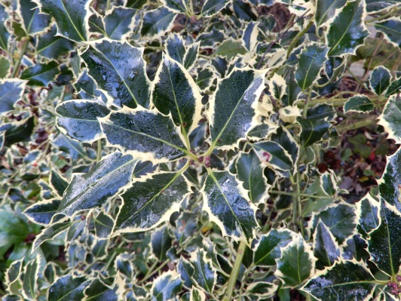
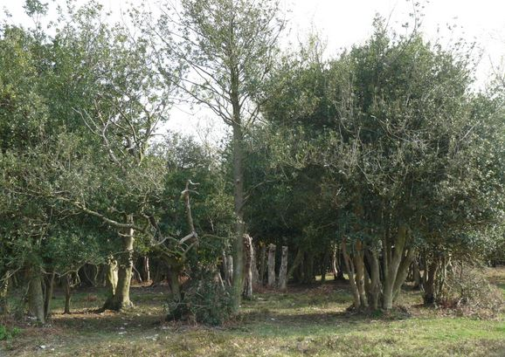
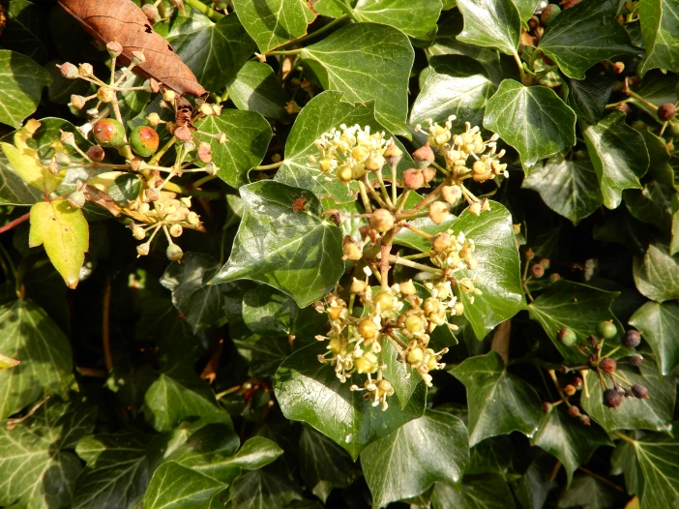
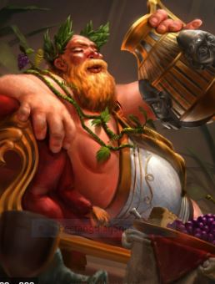
We like to stick a holly twig, preferably one with berries, in our Christmas pudding. Holly trees which can live for 300 years are dioecious i.e. they are either male or female plants. If you want berries buy a female tree, but it’s not that simple. Really attractive variegated trees are popular. They are called Silver Queen and Golden King. However, the horticulturists who named these varieties must have had too much Christmas cheer because Silver Queen is male and Golden King is female and therefore bears the berries. It’s bad luck to throw the twig on the fire after dinner. You need to put it on the garden or compost heap to save the luck. We all need lots of luck at present. For hundreds of years holly has been used as winter fodder for sheep and deer. What about the prickles you say? Leaves on mature branches have no prickles they are only on young shoots. Careful pruning produces a reliable crop. I come from a long line of New Forest gamekeepers whose main task was to look after the deer. Close to the site of my ancestral home, which is now a muddy mound near the middle of the forest, is a holly plantation from the days when the holly was used as a crop. You can see the great age of the trees. There are two main varieties of ivy, climbing ivy and ground ivy. Ivy is a very important plant as it supports a variety of creatures during the winter. It is very late flowering and the berries are relatively high in fat. This picture was taken last week and shows both the flowers and the berries. The flowers are a source of nectar for brave winter flying insects and the berries are a particular favourite of wood pigeons. Recently there have been requests to our local council to remove ivy from the trees in public places. There is a misunderstanding ivy is parasitic and harms the trees but this is not the case. Ivy climbs using using adventitious roots. These are roots which appear in places other than below ground. They are only a few millimetres long and never deeply penetrate the bark. A mature tree covered in ivy is an excellent habitat for at least 50 species of birds, small mammals and invertebrates so the growth should be maintained. Sometimes if the ivy spread laterally along high branches it may act as a sail in strong winds causing tree rock. Such trees are probably insecure anyway and could fall with or without the ivy and need to be dealt with. I always thought Bacchus, (Roman) or Dionysus (Greek) had a wreath of vine leaves around his head. They were in fact ivy leaves because they were supposed to stop you getting drunk. Try it this Christmas. Tim W 13/12/20

