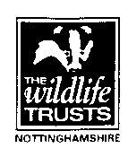

Major Funding Boost for Local Nature Reserves

Nottinghamshire Wildlife Trust and their South Notts Local Group are delighted to announce that the funding for important work at Wilwell Farm Cutting and Wilford Claypits nature reserves is now in place. These sites are two of Rushcliffe`s most important wildlife sites and are designated as Sites of Special Scientific Interest for their diverse flora and habitats.

The funding is coming from a variety of sources, with the Heritage Lottery Fund providing £9,500 to carry out scrub clearance on both sites, plus supporting a series of training courses in species ID and habitat survey techniques, as well as the production of interpretive material for the two reserves. Awards for All will be funding essential access work, practical nature conservation training and equipment to the tune of £8,797. In addition Rushcliffe Borough Council are providing another £1,750 towards habitat management on both sites. Whilst South Notts Local Group (NWT) will provide another £750 from local fund raising towards the project. When combined with the value of volunteer time, this represents a projected £28k boost.

Speaking about the funding boost, Gordon Dyne (Warden - Wilwell Farm Cutting Nature Reserve) said: “The support we have received directly from the Heritage Lottery Fund and the Big Lottery funded Awards for All programme will make a tremendous difference to two very important wildlife areas and will also help ensure that local volunteers are well trained and supported in their efforts to care for these special places.

This funding, along with the one million pound Skylarks Nature Reserve extension (also partly funded by Heritage Lottery as well as Lafarge Tarmac) and the Fairham Brook Enhancement Project (funded by the Environment Agency and SITA Trust) represents a significant ongoing commitment to nature conservation in Rushcliffe by the Wildlife Trust.

During the summer there will be opportunities to go on guided walks round Wilwell and Wilford Claypits to enjoy the delights of our local birds, butterflies, dragonflies and wildflowers. Initially this winter efforts will concentrate on getting some of the essential habitat work done and the conservation training completed.

If you want to know more about these reserves, or about opportunities to join the Wilford Claypits or Wilwell Nature Reserve work parties please go to our web site at http://www.southnottswildlife.org.uk/content/?page_id=22

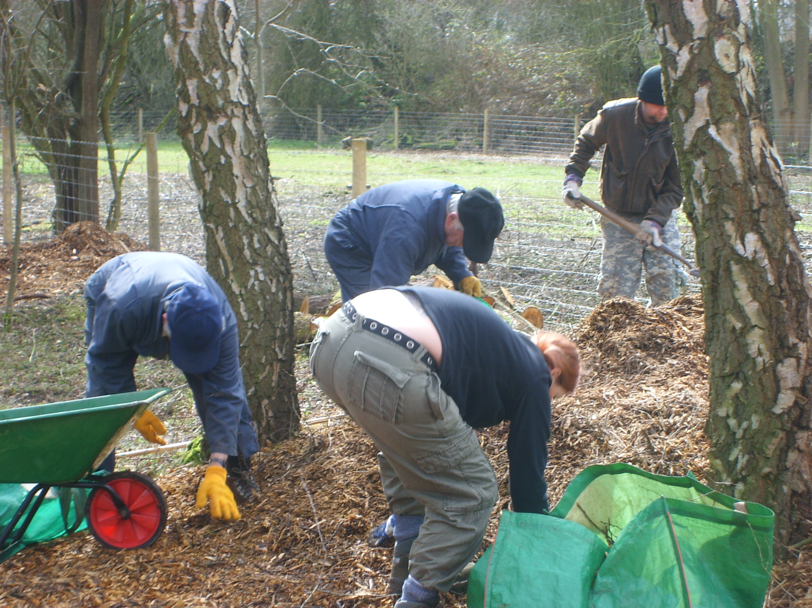

Volunteers at work at Wilwell Farm Cutting

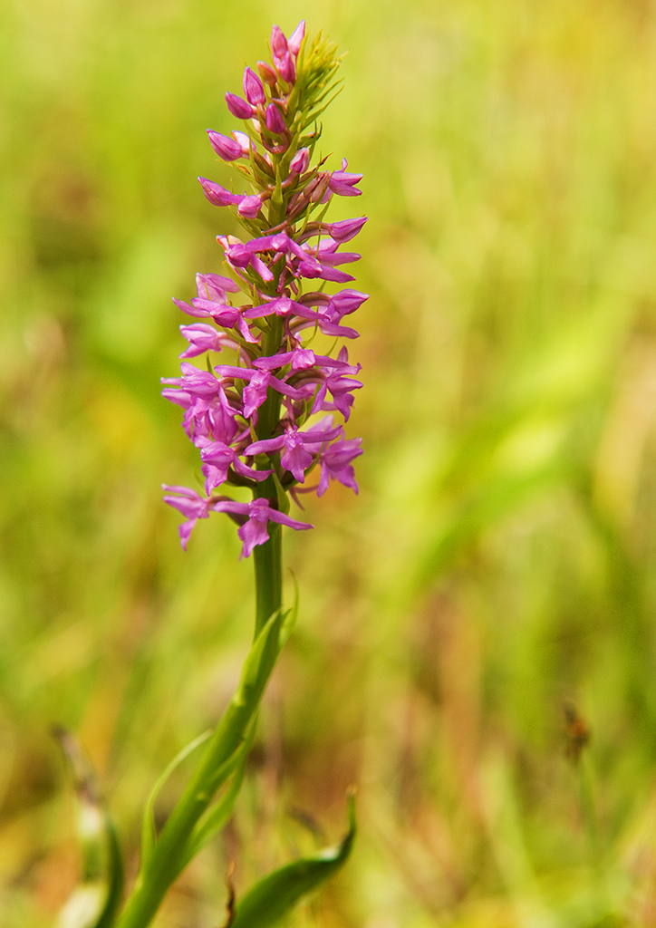

Fragrant Orchids at Wilford Claypits Nature Reserve

